Handling Input Gesture Listener

Multitouch
- Multitouch is technology that enables to recognize the presence of more than one, point of contact with the surface.
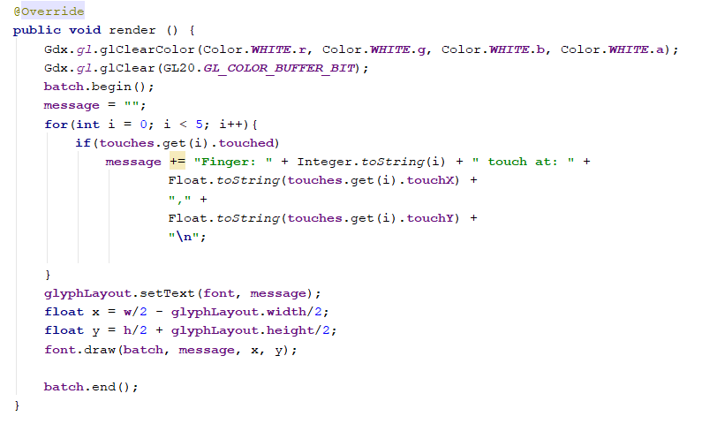

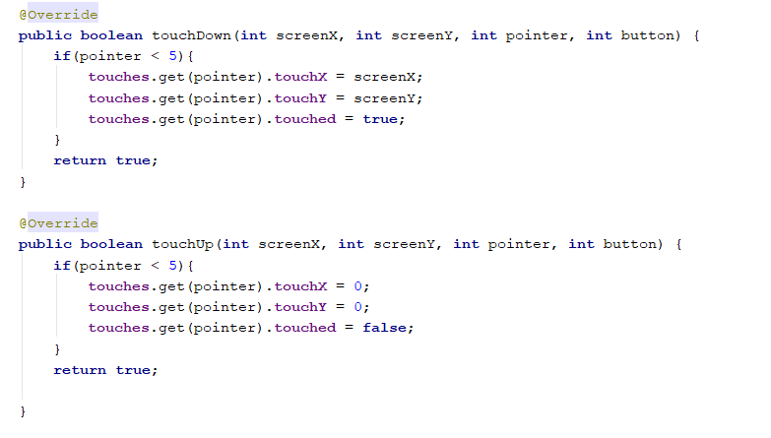

Touch Gestures
- Gesture Detection
  - Touch Down: A user touches the screen.
  - Long Press: A user touches the screen for a some time.
  - Tap: A user touches the screen and lift the finger again. The finger not move outside a specified square area.
  - Pan: A user drags a finger across the screen.
  - Pan Stop: Called when no longer panning.
  - Fling: a user dragged the finger across the screen, then lifted it(Swipe gestures).
  - Zoom: A user places two fingers on the screen and moves them together/apart.
  - Pinch: Similar to zoom. This is better use for a rotation.

